INTERVIEW NOTES

**SDLC: Waterfall and Agile**

1.What is the difference between waterfall and agile? Which one do you prefer?

|  |  |  |
| --- | --- | --- |
| No. | Waterfall | Agile |
| 1. | You can go to the next phase only after finishing the previous step | Agile is more flexible and if required you can go back to the previous phase |
| 2. | Product can be demoed to the customer only after all the phases are complete | Product can be demoed to the customer after every iteration |
| 3. | Issues in the product are found pretty late in the cycle | Issues are/can be found pretty early in the cycle |
|  |  |  |

2. What are some of the meetings you attended in agile?

* **Sprint Planning meeting:** Here we discuss our agenda for the sprint and who is going to work on which user story
* **Stand up meeting:** Daily status updates where we talk about what we did yesterday, what we are planning to do today and escalations if any
* **Mid Sprint review**: Checkpoint used to ensure team is on track to finish their tasks by the end of the sprint
* **Retrospective meeting**: Meeting used to understand how the team performed in the sprint and if the team did good, what they did well and if team feels they didnt do well, they what they didnt do right and how to fix it.
* **Release planning meeting**: This meeting is usually done quarterly or half yearly to look at what are the management goals and how they can be incorporated in terms of user stories

3. How many members in your agile team?

We have total of 7 members in our scrum team: 3 developers, 1 QA(myself), 1 User Experience Designer, Project manager, Product Manager

4. What are some of the challenges you have faced in agile?

There are two challenges I can think of

a. Code delivered very late in the sprint which leaves us very less time to test and automate

b. Too many changes in the user story till late in the sprint causes lot of churn for both developers and QA which makes it difficult to maintain test cases and automation.  
5. What do you do in retrospective meetings? Have you suggested changes in the retrospective meetings?

Some of the changes I have suggested in the retrospective meeting are

1. Suggestions on how code can be delivered earlier in the sprint and how QA can be involved in writing code in the first week of the sprint so as to finish the stories earlier
2. Give a definite deadline after which any changes to the user story are not acceptable in any given sprint.

6. Explain your experience with Agile methodology? What are some of the meetings that you attend as part of the Agile process.

->Same as 2

7. What is burn down chart?

A **burn down chart** is a graphical representation of work left to do versus time. The outstanding work (or backlog) is often on the vertical axis, with time along the horizontal. That is, it is a [run chart](http://en.wikipedia.org/wiki/Run_chart) of outstanding work. It is useful for predicting when all of the work will be completed. It is often used in [agile software development](http://en.wikipedia.org/wiki/Agile_software_development) methodologies such as [Scrum](http://en.wikipedia.org/wiki/Scrum_%28development%29). However, burn down charts can be applied to any project containing measurable progress over time.

8. What happens after you request a webpage on your browser. How is the page rendered?

a. Browser send the url to the DNS server which will translate the human readable website address to a ip address

b. Browser will now use this IP address to communicate with the web server

c. Now that the browser has established the connection, the browser will retrieve the HTML code to your browser

d. Once the browser has the HTML it will display the web page.

**FUNCTIONAL TESTING:**

1. What do you include in a test case (what are the different columns in a test case)?

Functional testing is a type of testing which verifies that each **function** of the software application operates in conformance with the requirement specification. This testing mainly involves black box testing and it is not concerned about the source code of the application.

Each and every functionality of the system is tested by providing appropriate input, verifying the output and comparing the actual results with the expected results. This testing involves checking of User Interface, APIs, Database, security, client/ server applications and functionality of the Application Under Test. The testing can be done either manually or using automation

 Important columns include:

     a. Test Case Name

     b. Steps

     c. Expected Result

     Other columns can be

     d. Actual Result

     e. Bug id

     f. Countries to execute tests on

     f. Automated

     g. Regression

2. What are the different test cases that you would write for testing [www.google.com](http://www.google.com/)?

3. Please review the Order confirmation page of [amazon.com](http://amazon.com/) and come up with 25 test cases for the same.

4. Explain Boundary value analysis with a small example.

 The input values at the extreme ends of input domain cause more errors in system. More application **errors occur at the boundaries** of input domain. ‘Boundary value analysis’ testing technique is used to identify errors at boundaries rather than finding those exist in center of input domain. e.g. if there is range of user names length can be between 6 and 16 characters, the tests that you can create using the boundary value analysis will include user names with length (5, 6, 10, 16,17)

5. What do you include in a test plan?

a. Introduction

     b. System Resources

     c.  Features to be tested

     d. System Resources

     e. Risk Assesment

     f. Test Criteria

     g. Roles and Responsibilities

**BUG Tracking: Jira**

1. What are the different Bug priorities?

Different priorities include

     P1 - Blocker

     P2 - Critical

     P3 - Major

     P4 - Minor

     P5 - Trivial

2. What is a bug life cycle?

**Defect life cycle or bug life cycle** is a cycle which a defect goes through during its lifetime. It starts when defect is found and ends when a defect is closed, after ensuring it’s not reproduced. [**Defect life cycle**](http://istqbexamcertification.com/what-is-a-defect-life-cycle/) is related to the bug found during testing.

1. **New:**  When a defect is logged and posted for the first time. It’s state is given as new.
2. **Assigned:**  After the tester has posted the bug, the lead of the tester approves that the bug is genuine and he assigns the bug to corresponding developer and the developer team. It’s state given as assigned.
3. **Open:** At  this state the developer has started analyzing and working on the defect fix.
4. **Fixed:** When developer makes necessary code changes and verifies the changes then he/she can make bug status as ‘Fixed’ and the bug is passed to testing team.
5. **Pending retest:**  After fixing the defect the developer has given that particular code for retesting to the tester. Here the testing is pending on the testers end. Hence its status is pending retest.
6. [**Retest**](http://istqbexamcertification.com/what-is-retesting/)**:**  At this stage the tester do the retesting of the changed code which developer has given to him to check whether the defect got fixed or not.
7. [**Verified**](http://istqbexamcertification.com/what-is-verification-in-software-testing-or-what-is-software-verification/)**:** The tester tests the bug again after it got fixed by the developer. If the bug is not present in the software, he approves that the bug is fixed and changes the status to “verified”.
8. **Reopen:** If the bug still exists even after the bug is fixed by the developer, the tester changes the status to “reopened”. The bug goes through the life cycle once again.
9. **Closed:** Once the bug is fixed, it is tested by the tester. If the tester feels that the bug no longer exists in the software, he changes the status of the bug to “closed”. This state means that the bug is fixed, tested and approved.
10. **Duplicate:** If the bug is repeated twice or the two bugs mention the same concept of the bug, then one bug status is changed to “duplicate**“.**
11. **Rejected:** If the developer feels that the bug is not genuine, he rejects the bug. Then the state of the bug is changed to “rejected”.
12. **Deferred:** The bug, changed to deferred state means the bug is expected to be fixed in next releases. The reasons for changing the bug to this state have many factors. Some of them are [**priority**](http://istqbexamcertification.com/what-is-the-difference-between-severity-and-priority/)of the bug may be low, lack of time for the release or the bug may not have major effect on the software.
13. **Not a bug:**  The state given as “Not a bug” if there is no change in the functionality of the application. For an example: If customer asks for some change in the look and field of the application like change of colour of some text then it is not a bug but just some change in the looks of the  application

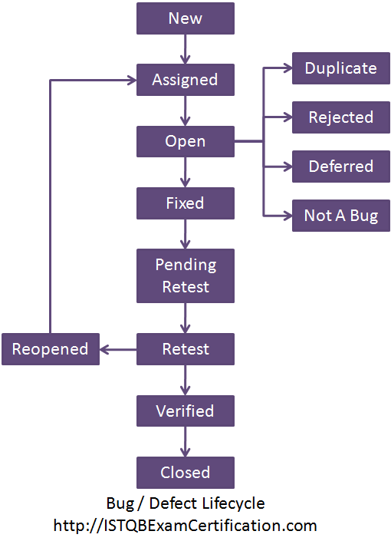

3. What do you include in a bug report?

 Bug report includes the following

     a. Summary

     b. Project the issue was found

     c. Priority

     d. Developer

     e. Reporter

     f. Steps to reproduce

     g. Current Result

     h. Expected Result

     i. Environment

     j. Screenshot

     k. Server logs

4. What do you do if you log a defect and the developer says he wont fix it?

Following things need to be done

     a.  Check the requirements and ensure it is truly an issue

     b.  Reproduce the issue again.

     c. If after a and b the developer still says he wont fix it, report it to the project manager

5. What steps do you take after you find a bug in production?

 Following things need to be done

     a. Try to reproduce the issue in staging/test environment

     b. If the issue is reproducible, identify the regression test cases

     c. Verify the bug fix and run the regression cases for getting the right coverage around the bug fix

6. Go to NBA.com and log five defects. Please make sure while logging defects that not only you understand what the issue is but it is put in a way that other person reading your bug understands it as well.

7. What is STLC? Explain with a block diagram?

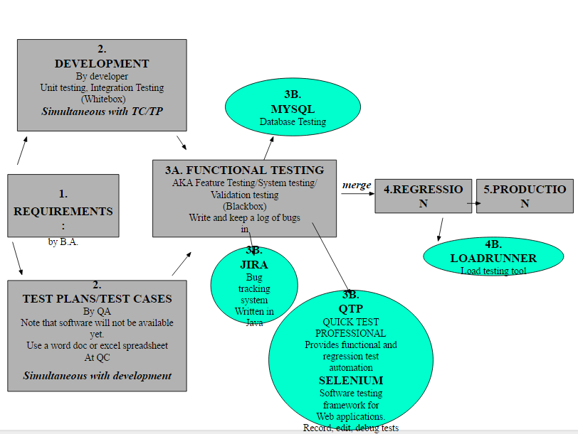

8. If you open a web page of your test application and the page keeps loading but never displays the full page how do you go about checking where the problem is?

There are two levels of checking that you would do

     a. Clear cache and cookies and reload the page

     b. Use firebug and see if there are any exceptions

     c. Connect to the server and see if there are any errors in the log

JIRA:y9

JIRA is a tool developed by Australian Company Atlassian. It is used for **bug tracking, issue tracking,** and **project management**. The basic use of this tool is to track issues, and bugs related to your software and[Mobile](http://www.guru99.com/mobile-testing.html)apps. It is also used for project management. The JIRA dashboard consists of many useful functions and features which make handling of issues easy

Scheme: Workflows, Issue Types, Custom Fields, Screens, Field Configuration, Notification, Permissions.

When issue is created in JIRA, it will be arranged and represented into different fields, this display of field in JIRA is known as a screen. This field can be transitioned and edited through workflow

A JIRA workflow is a set of statuses and transitions that an issue goes through during its lifecycle. JIRA workflow encompasses five main stages once the issue is created.

Open Issue, Resolved Issue, InProgress Issue, ReOpened Issue, Close Issue

**JAVA**

1. What is the main method in Java

main method in Java is a standard method which is used by JVM to start execution of any Java program. main method is referred as entry point of Java application. When we start JVM by running java command we also provide name of class which contains main method, which is later invoked by JVM to start Java program execution  
  
2. What is the meaning of the following keywords. Please explain in details public static void main (String args[])

* "public" means that main() can be called from anywhere.
* "static" means that main() doesn't belong to a specific object.
* "void" means that main() returns no value.
* "main" is the name of a function. main() is special because it is the start of the program.
* "String[]" means an array of String, "args" is the name of the String[] (within the body of main()). "args" is not special; you could name it anything else and the program would work the same.

3. What is the difference between abstract and interface

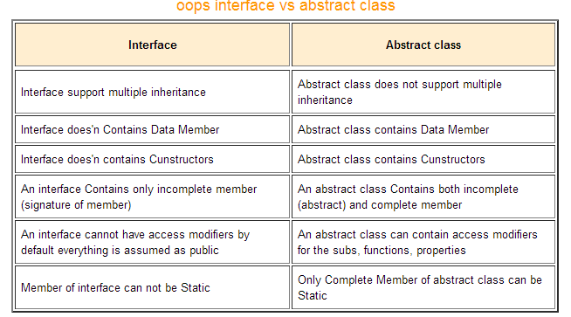

4. Define Class and Object in Java. Write an example for the same

* **Object** − Objects have states and behaviors. Example: A dog has states - color, name, breed as well as behaviors – wagging the tail, barking, eating. An object is an instance of a class.
* **Class** − A class can be defined as a template/blueprint that describes the behavior/state that the object of its type support.
* public class Puppy {
* public Puppy(String name) {
* // This constructor has one parameter, *name*.
* System.out.println("Passed Name is :" + name );
* }
* public static void main(String []args) {
* // Following statement would create an object myPuppy
* Puppy myPuppy = new Puppy( "tommy" );
* }
* }

5. What are the different access modifiers in Java. Explain by giving an example

There are two types of modifiers in java: **access modifiers** and **non-access modifiers**.

The access modifiers in java specifies accessibility (scope) of a data member, method, constructor or class.

There are 4 types of java access modifiers:

1. private
2. default
3. protected
4. public

There are many non-access modifiers such as static, abstract, synchronized, native, volatile, transient etc.

7. How do you do error handling in java, explain by giving an example

Java provides a powerful way to handle such exceptions which is known as exception handling. In it we write vulnerable code i.e. code which can throw exception in a separate block called as **try** block and exception handling code in another block called **catch**

Whenever an exception is caught corresponding catch block is executed, For example above code catches Arithmetic Exception only. If some other kind of exception is thrown it will not be caught so it's the programmer work to take care of all exceptions as in our try block we are performing arithmetic so we are capturing only arithmetic exceptions. A simple way to capture any exception is to use an object of Exception class as other classes inherit Exception class.

**class** Division {

**public** **static** **void** main(String[] args) {

**int** a, b, result;

Scanner input = **new** Scanner(System.in);

System.out.println("Input two integers");

a = input.nextInt();

b = input.nextInt();

*// try block*

**try** {

result = a / b;

System.out.println("Result = " + result);

}

*// catch block*

**catch** (ArithmeticException e) {

System.out.println("Exception caught: Division by zero.");

}

}

}

8. What is static in java. Can it be used with class, method and instance variables. If yes what difference does it make?

The **static keyword** in java is used for memory management mainly. We can apply java static keyword with variables, methods, blocks and nested class. The static keyword belongs to the class than instance of the class.

The static can be:

1. variable (also known as class variable)
2. method (also known as class method)
3. block
4. nested class

**If you declare any variable as static**, it is known static variable.

* The static variable can be used to refer the common property of all objects (that is not unique for each object) e.g. company name of employees,college name of students etc.
* The static variable gets memory only once in class area at the time of class loading.

Advantage of static variable

It makes your program **memory efficient** (i.e it saves memory).

**If you apply static keyword with any method**, it is known as static method.

* A static method belongs to the class rather than object of a class.
* A static method can be invoked without the need for creating an instance of a class.

|  |
| --- |
| static method can access static data member and can change the value of it. There are two main restrictions for the static method. They are: |

|  |
| --- |
| 1. The static method can not use non static data member or call non-static method directly. 2. this and super cannot be used in static context.   **Static Block** |

* Is used to initialize the static data member.
* It is executed before main method at the time of classloading.

9. What is inheritance in java?

Inheritance can be defined as the process where one class acquires the properties (methods and fields) of another. With the use of inheritance the information is made manageable in a hierarchical order.

The class which inherits the properties of other is known as subclass (derived class, child class) and the class whose properties are inherited is known as superclass (base class, parent class).

**extends** is the keyword used to inherit the properties of a class.

10. Explain method overriding

If a class inherits a method from its superclass, then there is a chance to override the method provided that it is not marked final.

The benefit of overriding is: ability to define a behavior that's specific to the subclass type, which means a subclass can implement a parent class method based on its requirement.

In object-oriented terms, overriding means to override the functionality of an existing method.

11. Explain encapsulation?

**Encapsulation** is one of the four fundamental OOP concepts. The other three are inheritance, polymorphism, and abstraction.

Encapsulation in Java is a mechanism of wrapping the data (variables) and code acting on the data (methods) together as a single unit. In encapsulation, the variables of a class will be hidden from other classes, and can be accessed only through the methods of their current class. Therefore, it is also known as **data hiding**.

To achieve encapsulation in Java –Declare the variables of a class as private.

* Provide public setter and getter methods to modify and view the variables values

12. What are the steps for connecting to a database? Please provide and example

13. What are the steps to read write to a text file? Please provide an example.

It Is very easy to Create, Write and read text file In java software development language.

We can use java built in class **File**to create new file, **FileWriter**and **BufferedWriter**class to write In to file, **FileReader**and **BufferedReader**class to read text file.

14. What is a user defined exception?

class MyException extends Exception {

String s1;

MyException(String s2) {

s1 = s2;

}

@Override

public String toString() {

return ("Output String = "+s1);

}

}

public class NewClass {

public static void main(String args[]) {

try {

throw new MyException("Custom message");

} catch(MyException exp) {

System.out.println(exp);

}

}

15. What is the difference between method overloading and method overriding?

1)  
Method overloading is used *to increase the readability* of the program.  
Method overriding is used *to provide the specific implementation* of the method that is already provided by its super class.

2)  
Method overloading is performed *within class*. Method overriding occurs *in two classes* that have IS-A (inheritance) relationship.

3)

In case of method overloading, *parameter must be different*. In case of method overriding, *parameter must be same*.

4)  
Method overloading is the example of *compile time polymorphism*. Method overriding is the example of *run time polymorphism*.

5)  
In java, method overloading can't be performed by changing return type of the method only. *Return type can be same or different* in method overloading. But you must have to change the parameter. *Return type must be same or covariant* in method overriding.

|  |  |  |  |
| --- | --- | --- | --- |
| **No.** | **final** | **finally** | **finalize** |
| 1) | Final is used to apply restrictions on class, method and variable. Final class can't be inherited, final method can't be overridden and final variable value can't be changed. | Finally is used to place important code, it will be executed whether exception is handled or not. | Finalize is used to perform clean up processing just before object is garbage collected. |
| 2) | Final is a keyword. | Finally is a block. | Finalize is a method. |

16. What is the difference between final, finally and finalize keywords

17. What is the difference between array and arraylist?

**1. Resizable :**   Array is static in size that is fixed length data structure, One can not change the length after creating the Array object.  
ArrayList is dynamic in size . Each ArrayList object  has instance variable *capacity* which indicates the size of the ArrayList. As elements are added to an ArrayList its capacity grows automatically.  
  
**2. Performance :** Performance of Array and ArrayList depends on the operation you are performing :  
  
*resize() opertation :* Automatic resize of ArrayList will slow down the performance as it will use temporary array to copy elements from the old array to new array.  
ArrayList is internally backed by Array during resizing  as it calls the native implemented method System.arrayCopy(src,srcPos,dest,destPos,length).  
  
  
*add() or get() operation :* adding an element or retrieving an element from the array or arraylist object has almost same  performance , as for ArrayList object these operations  run in constant time.  
  
**3. Primitives :**  ArrayList can not contains primitive data types (like int , float , double) it can only contains Object while Array can contain both primitive data types as well as objects.  
One get a misconception that we can store primitives(int,float,double) in ArrayList , but it is not true    
  
Suppose we have ArrayList object ,

ArrayList  arraylistobject = new ArrayList();  
arraylistobject.add(**23**);  // try to add 23 (primitive)

JVM through Autoboxing(converting primitives to equivalent objects internally) ensures that only objects are added to the arraylist object.   
thus , above step internally works like this :

arraylistobject.add( **new Integer(23)**);         
// Converted int primitive to Integer object and added to arraylistobject

**4. Iterating the values :** We can use iterator  to iterate through ArrayList . The iterators returned by the ArrayList class's iterator and listiterator method are [fail-fast](http://javahungry.blogspot.ca/2014/04/fail-fast-iterator-vs-fail-safe-iterator-difference-with-example-in-java.html).  We can use for loop or for each loop to iterate through array .    
  
**5. Type-Safety :**In Java , one can ensure Type Safety through Generics. while Array is a homogeneous data structure , thus it will contain objects of specific class or primitives of specific  data type. In array if one try to store the different data type other than the specified while creating the array object , ArrayStoreException is thrown.  
  
for example :

String temp[] =  new String[2];  // creates a string array of size 2  
temp[0] = new Integer(12); // throws ArrayStoreException, trying to add Integer object in String[]

**6. Length :**Length of the ArrayList is provided by the size() method while Each array object has the length variable which returns the length of the array.  
  
for example :

Integer arrayobject[] = new Integer[3];  
arraylength= arrayobject.length   ;  //uses arrayobject length variable

ArrayList  arraylistobject = new ArrayList();  
arraylistobject.add(12);   
arraylistobject.size();   //uses arraylistobject size method

**7. Adding elements :** We can insert elements into the arraylist object using the add() method while  in array we insert elements using the assignment operator.  
  
  
for example :

Integer addarrayobject[] = new Integer[3];  
addarrayobject[0]= new Integer(8)   ;  //new object is added to the array object

**8. Multi-dimensional :**Array can be multi dimensional , while ArrayList is always single dimensional.  
  
example of multidimensional array:

Integer addarrayobject[][] = new Integer[3][2];  
addarrayobject[0][0]= new Integer(8)

18. What is synchronisation in java?

Synchronization is the process of allowing threads to execute one after another.  
  
Synchronization control the access the multiple threads to a shared resources. Without synchronization of threads, one thread can modify a shared variable while another thread can update the same shared variable, which leads to significant errors

Java supports multiple threads to be executed. This may cause two or more threads to access the same fields or objects. Synchronization is a process which keeps all concurrent threads in execution to be in synch. Synchronization avoids memory consistence errors caused due to inconsistent view of shared memory. When a method is declared as synchronized; the thread holds the monitor for that method's object If another thread is executing the synchronized method, your thread is blocked until that thread releases the monitor.

**TESTNG:**  
1. What is an error collector in testing?

While writing automation scripts we may want to continue the execution of our script to continue even if any of the line has failed due to various reasons like “GUI assertion failure” etc. In that case we can use the ErrorCollector object to add collect all the error which comes up with script execution and report it only at the end. Object of this class is created with the annotation @Rule. You can add errors by calling the method addError(Throwable error), which adds a Throwable to the table. Throwable is the parent calss of all errors and exceptions in java. When you add errors like this, these errors will be automatically logged to junit test results as well

2. How does a testng listener work?

Listener is defined as interface that modifes the default TestNG's behavior. As the name suggests Listeners "listen" to the event defined in the selenium script and behave accordingly. It is used in selenium by implementing Listeners Interface. It allows customizing TestNG reports or logs. There are many types of TestNG listeners available.

3. What flag do you use to skip a test?

5. Expalin use of groups in testing?

We use groups in TestNG when,

* We don't want to define test methods separately in different classes (depending upon functionality) and
* At the same time want to ignore (not to execute) some test cases as if they does not exist in the code.
* So to carry out this we have to Group them. This is done by using "include" and "exclude" mechanism supported in testNG.

1. What is data driven testing in testng and how is it different than parameterised test in JAVA?

Data-driven testing is creation of test scripts where test data and/or output values are read from data files instead of using the same hard-coded values each time the test runs. This way, testers can test how the application handles various inputs effectively. It can be any of the below data files.

* Datapools
* Excel files
* ADO objects
* CSV files
* ODBC sources

@TEst

@Parameters({“username”,”Password”})

public void test(String sUsername, String sPassword) {

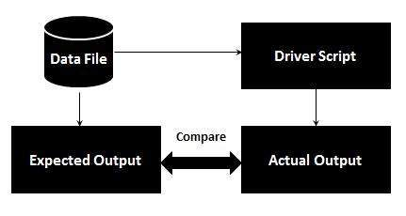

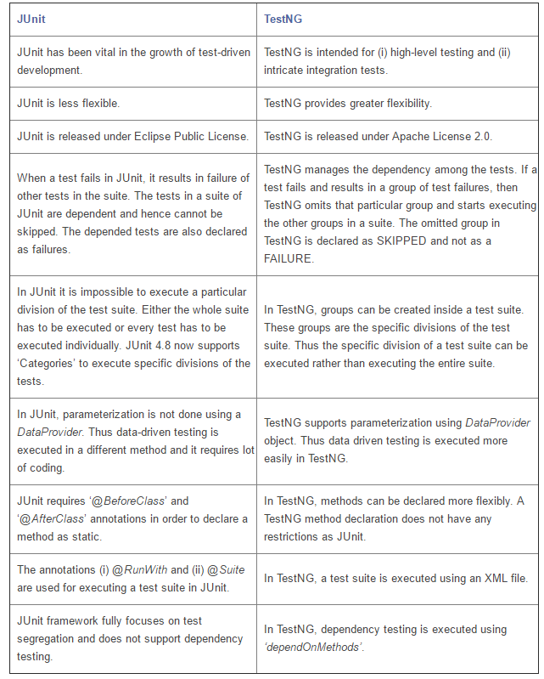

7. What is dependency test in testng?

Dependency is a feature in TestNG that allows a test method to depend on a single or a group of test methods. This will help in executing a set of tests to be executed before a test method.

The dependency on multiple test methods is configured for a test by providing comma separated dependent test method names to the attribute **dependsOnMethods** while using the Test annotation.

The following example shows a test class where process() test method depends on multiple test methods start() and initi() of the same class

package com.skilledmonster.example;

import org.testng.annotations.Test;

/**

* Example to demonstrate TestNG multiple dependency method execution

* @author Jagadeesh Motamarri

* @version 1.0

*/

public class MultipleDependencyTest {

@Test

public void start() {

System.out.println("Starting the server");

}

@Test(dependsOnMethods = { "start" })

public void init() {

System.out.println("Initializing the data for processing!");

}

@Test(dependsOnMethods = { "start", "init" })

public void process() {

System.out.println("Processing the data!");

}

@Test(dependsOnMethods = { "process" })

public void stop() {

System.out.println("Stopping the server");

}

}

1. What are the different types of commands in selenium called as?

In general, Selenium commands come in three types: **Actions, Accessors, and Assertions.**

**Actions** do thing like "Click this link", "ClickAndWait", "WaitForPageToLoad" and select that option. If an action fails, or has an error, the execution of the current test is stopped. Actions are generally used for human action simulation when interacting with web elements.

**Accessors** are used to store the results in variables. For example, "StoreTitle", "StoreVariable". They are also used to automatically generate Assertions.

**Assertion** are like Accessors, but they verify that the state of the application conforms to what is expected. Examples include “make sure the page title is X” and “verify that this checkbox is checked”.

2. What are the different types of locators in selenium and which is the most prefered one and why?

3. What is the differnece between assert and verify

**Assert command in selenium:**

When an “assert” command fails, the test execution will be aborted. So when the Assertion fails, all the test steps after that line of code are skipped. The solution to overcoming this issue is to use a try-catch block. We use the Assertion in the try catch block. Mostly, the assert command is used when the end result of the check value should pass to continue to the next step.

In simple words, if the assert condition is true then the program control will execute the next test step but if the condition is false, the execution will stop and further test step will not be executed.  
To overcome this we use Soft Assert in TestNG. Checkout below post to know what is Soft Assert.

**Verify command in selenium:**When a “verify” command fails, the test will continue executing and logging the failure. Mostly, the Verify command is used to check non-critical things. In such cases where we move forward even though the end result of the check value is failed.

if(isElementPresent(By.linkText("Submit")))

if(driver.getPageSource().contains("Text - Testing with Arif"))

{

System.out.println("Text is Present");

}

else

{

System.out.println("Text is not Present");

}

In simple words, there wont be any halt in the test execution even though the verify condition is true or false.

**Note:** In TestNG, we use only Assert Statements.

4. What are store commands used for in selenium  
5. What is the difference between asserttext vs asserttextpresent?  
6. What are the differnt components in selenium

* Selenium IDE.
* Selenium client API.
* Selenium Remote Control.
* Selenium WebDriver.
* Selenium Grid.

7. How to verify the contents on a page when the text to be verified doesnt have id or a name.

**Black Box Testing**

Black box testing is a software testing techniques in which functionality of the software under test (SUT) is tested without looking at the internal code structure, implementation details and knowledge of internal paths of the software. 7This type of testing is based entirely on the software requirements and specifications.

In BlackBox Testing we just focus on inputs and output of the software system without bothering about internal knowledge of the software program.

Types:

* **Functional testing** - This black box testing type is related to functional requirements of a system; it is done by software testers.
* **Non-functional testing**- This type of black box testing is not related to testing of a specific functionality, but non-functional requirements such as performance, scalability, usability.
* **Regression testing**- Regression testing is done after code fixes, upgrades or any other system maintenance to check the new code has not affected the existing code.

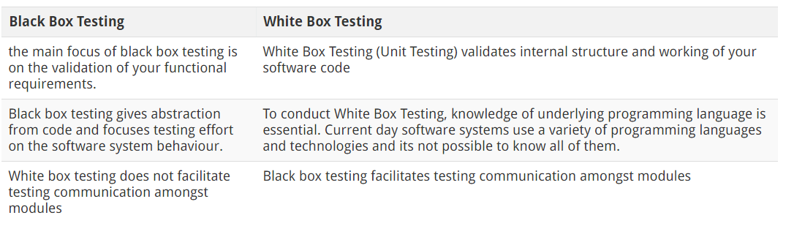

**Traceability Matrices**

A traceability matrix is a document that co-relates any two-baseline documents that require a many-to-many relationship to check the completeness of the relationship.

It is used to track the requirements and to check the current project requirements are met.

Requirement Traceability Matrix or RTM captures all requirements proposed by the client or development team and their traceability in a single document delivered at the conclusion of the life-cycle.

In other words, it is a document that maps and traces user requirement with test cases. The main purpose of Requirement Traceability Matrix is to see that all test cases are covered so that no functionality should miss while testing.

Parameters:

Requirement ID, Risks, Requirement Type and Description, Trace to design specification, Unit test cases, Integration test cases, System test cases, User acceptance test cases, Trace to test script

Advantages

* It confirms 100% test coverage
* It highlights any requirements missing or document inconsistencies
* It shows the overall defects or execution status with a focus on business requirements
* It helps in analyzing or estimating the impact on the QA team's work with respect to revisiting or re-working on the test cases

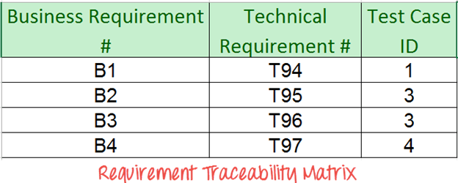

**Integration Testing**

In Integration Testing, **individual software modules are integrated logically** and tested as a group.

A typical software project consists of multiple software modules, coded by different programmers.

 Integration testing focuses on checking data communication amongst these modules.

Hence it is also termed as 'I & T' (Integration and Testing), 'String Testing' and sometimes 'Thread Testing'.

### Why do Integration Testing?

Although each software module is unit tested, defects still exist for various reasons like

* A Module in general is designed by an individual software developer whose understanding and programming logic may differ from other programmers. Integration testing becomes necessary to verify the software modules work in unity
* At the time of module development, there are wide chances of change in requirements by the clients. These new requirements may not be unit tested and hence system integration testing becomes necessary.
* Interfaces of the software modules with the database could be erroneous
* External Hardware interfaces, if any, could be erroneous
* Inadequate exception handling could cause issues.

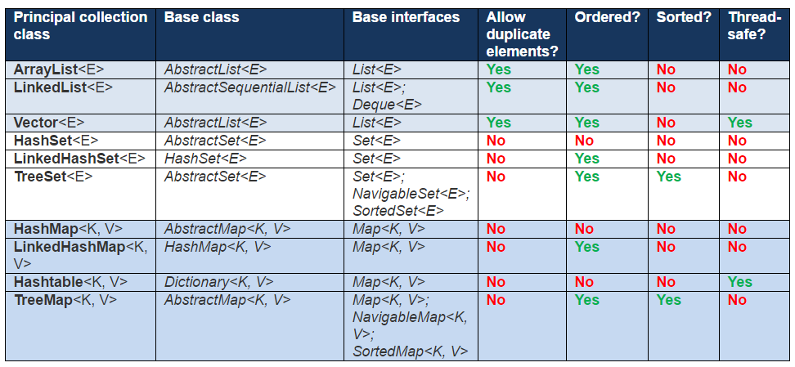

**SORTING ALGORITHMS**

1. **Bubble Sort**

Bubble sort is a simple sorting algorithm. This sorting algorithm is comparison-based algorithm in which each pair of adjacent elements is compared and the elements are swapped if they are not in order. This algorithm is not suitable for large data sets as its average and worst case complexity are of Ο(n2) where n is the number of items.

begin BubbleSort(list)

for all elements of list

if list[i] > list[i+1]

swap(list[i], list[i+1])

end if

end for

return list

end BubbleSort

1. **Insertion Sort**

This is an in-place comparison-based sorting algorithm. Here, a sub-list is maintained which is always sorted. For example, the lower part of an array is maintained to be sorted. An element which is to be 'insert'ed in this sorted sub-list, has to find its appropriate place and then it has to be inserted there. Hence the name, **insertion sort**.

The array is searched sequentially and unsorted items are moved and inserted into the sorted sub-list (in the same array). This algorithm is not suitable for large data sets as its average and worst case complexity are of Ο(n2), where **n** is the number of items.

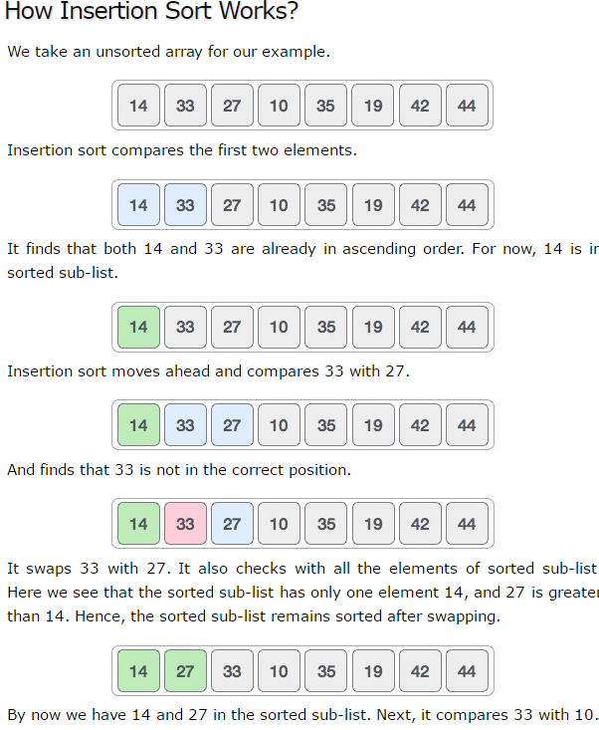

1. **Selection Sort**

The smallest element is selected from the unsorted array and swapped with the leftmost element, and that element becomes a part of the sorted array. This process continues moving unsorted array boundary by one element to the right.

This algorithm is not suitable for large data sets as its average and worst case complexities are of Ο(n2), where n is the number of items.

1. **Merge Sort**

Merge sort is a sorting technique based on divide and conquer technique. With worst-case time complexity being Ο(n log n), it is one of the most respected algorithms.

Merge sort first divides the array into equal halves and then combines them in a sorted manner.

1. **Quick Sort**

Quick sort is a highly efficient sorting algorithm and is based on partitioning of array of data into smaller arrays. A large array is partitioned into two arrays one of which holds values smaller than the specified value, say pivot, based on which the partition is made and another array holds values greater than the pivot value.

Quick sort partitions an array and then calls itself recursively twice to sort the two resulting subarrays. This algorithm is quite efficient for large-sized data sets as its average and worst case complexity are of Ο(n2), where **n** is the number of items.

**Cloud: environment**

**Dev(developement)**

**QA**

**PreProd**

**Prod(real)**

**Web Services:**

## **Example**

Consider a simple account-management and order processing system. The accounting personnel use a client application built with Visual Basic or JSP to create new accounts and enter new customer orders.

The processing logic for this system is written in Java and resides on a Solaris machine, which also interacts with a database to store information.

The steps to perform this operation are as follows:

* The client program bundles the account registration information into a SOAP message.
* This SOAP message is sent to the web service as the body of an HTTP POST request.
* The web service unpacks the SOAP request and converts it into a command that the application can understand.
* The application processes the information as required and responds with a new unique account number for that customer.
* Next, the web service packages the response into another SOAP message, which it sends back to the client program in response to its HTTP request.
* The client program unpacks the SOAP message to obtain the results of the account registration process.

**For those of you wanting to add the possibility to validate RESTful web services to your test automation framework, REST Assured can be a very useful way to do just that**

**Q-1. Explain REST?**

**Ans.** REST stands for Representational State Transfer. REST is an architectural style of developing web services which take advantage of the ubiquity of HTTP protocol and leverages HTTP method to define actions. It revolves around resource where every component is a resource which can be accessed by a common interface using HTTP standard methods.

In REST architecture, a REST Server provides access to resources and REST client accesses and presents those resources. Here each resource is identified by URIs or global IDs. REST uses different ways to represent a resource like text, JSON, and XML.XML and JSON are the most popular representations of resources these days.

**Q-2. Explain The RESTFul Web Service?**

**Ans.** Mostly, there are two kinds of Web Services which are quite popular.

**1.** SOAP (Simple Object Access Protocol) which is an XML-based way to expose web services.

**2.** Web services developed using REST style are known as RESTful web services. These web services use HTTP methods to implement the concept of REST architecture. A RESTful web service usually defines a URI, Uniform Resource Identifier a service, provides resource representation such as JSON and set of HTTP Methods.

**Q-3. Explain What Is A “Resource” In REST?**

**Ans.** REST architecture treats every content as a resource. These resources can be either text files, HTML pages, images, videos or dynamic business data.

REST Server provides access to resources and REST client accesses and modifies these resources. Here each resource is identified by URIs/ global IDs.

**Q-4. What Is The Most Popular Way To Represent A Resource In REST?**

**Ans.** REST uses different representations to define a resource like text, JSON, and XML.

XML and JSON are the most popular representations of resources.

**Q-5. Which Protocol Is Used By RESTful Web Services?**

**Ans.** RESTful web services make use of HTTP protocol as a medium of communication between client and server.

**Q-6. What Is Messaging In RESTful Web Services?**

**Ans.** RESTful web services make use of HTTP protocol as a medium of communication between client and server. The client sends a message in the form of an HTTP Request.

In response, the server transmits the HTTP Response. This technique is called Messaging. These messages contain message data and metadata i.e. information about the message itself.

**Q-7. State The Core Components Of An HTTP Request?**

**Ans.** Each HTTP request includes five key elements.

**1.** The Verb which indicates HTTP methods such as GET, PUT, POST, DELETE.  
**2.** URI stands for Uniform Resource Identifier (URI).It is the identifier for the resource on the server.  
**3.** HTTP Version which indicates HTTP version, for example-HTTP v1.1.  
**4.** Request Header carries metadata (as key-value pairs) for the HTTP Request message. Metadata could be a client (or browser) type, the format that client supports, message body format, and cache settings.  
**5.** Request Body indicates the message content or resource representation.

**Q-8. State The Core Components Of An HTTP Response?**

**Ans.** Every HTTP response includes four key elements.

**1.** Status/Response Code – Indicates Server status for the resource present in the HTTP request.For example, 404 means resource not found and 200 means response is ok.  
**2.** HTTP Version – Indicates HTTP version, for example-HTTP v1.1.  
**3.** Response Header – Contains metadata for the HTTP response message stored in the form of key-value pairs. For example, content length, content type, response date, and server type.  
**4.** Response Body – Indicates response message content or resource representation.

**Q-9. Name The Most Commonly Used HTTP Methods Supported By REST?**

**Ans.** There are a few HTTP methods in REST which are more popular.

**1.** GET -It requests a resource at the request-URL. It should not contain a request body as it will get discarded. Maybe it can be cached locally or on the server.  
**2.** POST – It submits information to the service for processing; it should typically return the modified or new resource.  
**3.** PUT – At the request URL it updates the resource.  
**4.** DELETE – It removes the resource at the request-URL.  
**5.** OPTIONS -It indicates the supported techniques.  
**6.** HEAD – It returns meta information about the request URL.

**Q-10. Mention, Whether You Can Use GET Request Instead Of PUT, To Create A Resource?**

**Ans.** No, you shouldn’t use a PUT or POST method. Instead, apply the GET operation which has view-only rights.

**Q-11. Is There Any Difference Between PUT And POST Operations? Explain It.**

**Ans.** PUT and POST operation are almost same. The only difference between the two is in the terms of the result generated by them.

PUT operation is idempotent while POST operation can give a different result.

Let’s take an example.

**1.** PUT puts a file or resource at a particular URI and exactly at that URI. If the resource already exists, then PUT updates it. If it’s a first-time request, then PUT creates one.  
**2.** POST sends data to a particular URI and expects the resource at that URI to deal with the request. The web server at this point can decide what to do with the data in the context of specified resource.

**Q-12. What Purpose Does The OPTIONS Method Serve For The RESTful Web Services?**

**Ans.** This method lists down all the operations a web service supports. It makes read-only requests to the server.

**Q-13. What Is URI? Explain Its Purpose In REST Based Web Services. What Is Its Format?**

**Ans.** URI stands for Uniform Resource Identifier. URI is the identifier for the resource in REST architecture.

The purpose of a URI is to locate a resource(s) on the server hosting the web service. A URI is of the following format-

**<protocol>://<service-name>/<ResourceType>/<ResourceID>**

**Q-14. What Do You Understand By Payload In RESTFul Web Service?**

**Ans.** Request body of every HTTP message includes request data called as Payload. This part of the message is of interest to the recipient.

We can say that we send the payload in POST method but not in <GET> and <DELTE> methods.

**Q-15. What Is The Upper Limit For A Payload To Pass In The POST Method?**

**Ans.** <GET> appends data to the service URL. But, its size shouldn’t exceed the maximum URL length. However, <POST> doesn’t have any such limit.

So, theoretically, a user can pass unlimited data as the payload to POST method. But, if we consider a real use case, then sending POST with large payload will consume more bandwidth. It’ll take more time and present performance challenges to your server. Hence, a user should take action accordingly.

**Q-16. Explain The Caching Mechanism?**

**Ans.** Caching is a process of storing server response at the client end. It makes the server save significant time from serving the same resource again and again.

The server response holds information which leads a client to perform the caching. It helps the client to decide how long to archive the response or not to store it at all.

**Q-17. List The Main Differences Between SOAP And REST?**

**Ans.**

|  |  |
| --- | --- |
| **SOAP** | **REST** |
| **1.** SOAP is a protocol through which two computer communicates by sharing XML document. | **1.** Rest is a service architecture and design for network-based software architecture. |
| **2.** SOAP supports the only XML format. | **2.** It supports many different data formats. |
| **3.** SOAP does not support caching. | **3.** It supports caching. |
| **4.** SOAP is like custom desktop application, closely connected to the server. | **4.** A REST client is just like a browser and uses standard methods. An application has to fit inside it. |
| **5.** SOAP is slower than REST. | **5.** It is faster than SOAP. |
| **6.** It runs on HTTP but envelopes the message. | **6.** It uses the HTTP headers to hold meta information. |

**Q-18. What Are The Tools Available For Testing Web Services?**

**Ans.** Following tools can help in testing the SOAP and RESTful web services.

**1.** SOAP UI tool.  
**2.** Poster for Firefox browser.  
**3.** The Postman extension for Chrome.

**Q-19. Explain The Factors That Help To Decide About The Style Of Web Service To Use? SOAP Or REST?**

**Ans.** In general, using REST based web service is preferred due to its simplicity, performance, scalability, and support for multiple data formats.

However, SOAP is favorable to use where service requires an advanced level of security and transactional reliability.

But you can read the following facts before opting for any of the styles.

**1.** Does the service expose data or business logic? To expose data REST will be a better choice and SOAP for logic.  
**2.** If the consumer or the service providers require a formal contract, then SOAP can provide such a contract via WSDL.  
**3.** Need to support multiple data formats. REST supports this.  
**4.** Support for AJAX calls. REST can use the XMLHttpRequest.   
**5.** Synchronous and asynchronous calls – SOAP enables both synchronous/asynchronous operations whereas REST has built-in support for synchronous.  
**6.** Stateless or Stateful calls -REST is suited for stateless operations.

Here are some of the advanced-level facts that you can consider as well.

**1.** Security requirement – SOAP provides a high level of security.  
**2.** Transaction support – SOAP has good support for transaction management.  
**3.** Limited bandwidth – SOAP has a lot of overhead when sending/receiving packets since it’s XML based, requires a SOAP header. However, REST requires less bandwidth to send requests to the server. Its messages are mostly built using JSON.  
**4.** Ease of use – It is easy to implement, test, and maintain REST based application.

**Q-20. Can You Tell Us Which Java API Helps In Developing A RESTFul Web Service?**

**Ans.** There are many frameworks and libraries available that a developer can use to create RESTful web services in Java. For example, the JAX-RS library is a standard way to develop a REST web service.

Also, Jersey is another most popular implementations of JAX-RS which offers more than what the specs recommend. There are others like RESTEasy, RESTlet, and Apache CFX.

If you like Scala, then you should be using Play framework to develop RESTful web services.

**Difference between Set, List and Map**

Difference between Set, List and Map

Set, List and Map are very important [interfaces](http://data-structure-learning.blogspot.com/2015/05/java-collections-part-2-interfaces.html) in [Java Collections Framework](http://data-structure-learning.blogspot.com/2015/05/java-collections-part-1.html).

We have studied List, Set and Map interfaces as individual. We also saw [difference between List and Set](http://data-structure-learning.blogspot.com/2015/05/difference-between-list-and-set.html) and [when to you either of them](http://data-structure-learning.blogspot.com/2015/05/when-to-use-list-and-set.html).

In this post we will compare all 3 of them i.e. Set, List and Map.

Let us first see all of them individually

•         Set – Provides a mathematical abstraction of Set. No duplicates allowed. Unordered Collection.

•         [List](http://data-structure-learning.blogspot.com/2015/05/java-collections-part-5list-interface.html) – Index and Ordered Collection. Duplicated allowed.

•         [Map](http://data-structure-learning.blogspot.com/2015/05/java-collections-part-3map-interface.html) – Provides one to one mapping or injective function. Unordered Collection.

There are several concrete implementations of this interfaces provided in Collections Framework.

Now let us see the difference between these 3 interfaces.

•         Ordered or Unordered Collection

1.  List – **List** is **ordered collection**. List defines a contract of maintaining insertion order and its concrete implementations follow that contract.

2.  Set – **Set** is **unordered collection**. The contract does not specify any type of insertion order. But it specify contract of unique elements in Set. LinkedHashSet maintains the insertion order. TreeSet maintains the sorting order.

3.  Map – **Map** is **unordered collection**. The contract specifies that keys much be unique and values can be repeated for different keys. Insertion order is not maintained. LinkedHashMap maintains the insertion order. TreeMap maintains the sorting order.

•         Duplicate elements

1.   List – **List** can **hold duplicate elements** or objects in to it.

2.   Set – **Set** interface has a **contract for unique elements** and all the implementation of Set interface uphold this contract.

3.  Map – **Map** interface has **contract of unique keys**. Map has an entry which has key and value. All keys in Map must be unique; values can be unique or repeated.

•         Null elements

1.     List – **List** can hold **multiple null elements** as it allows duplicates elements.

2.    Set – **Set** allows **single null element** because it has contract of unique elements.

3.    Map- **Map** allows **Single null key and multiple null values**. It actually depends on various implementations. For example, Hashtable does not allow null key or value neither does ConcurrentHashMap. [HashMap vs. Hashtable](http://data-structure-learning.blogspot.com/2015/05/difference-between-hashtableand-hashmap.html) is popular interview question too.

**Synchronization or Thread Safe :**  This is the most important difference between two . HashMap is non synchronized and not thread safe.On the other hand, HashTable is thread safe and synchronized.  
When to use HashMap ?  answer is if your application do not require any multi-threading task, in other words hashmap is better for non-threading applications. HashTable should be used in multithreading applications.   
  
**2. Null keys and null values :**  Hashmap allows one null key and any number of null values, while Hashtable do not allow null keys and null values in the HashTable object.  
  
  
  
**3. Iterating the values:**  Hashmap object values are iterated by using iterator .HashTable is the only class other than vector which uses enumerator to iterate the values of HashTable object.

**4.  Fail-fast iterator**  : The iterator in Hashmap is fail-fast iterator while the enumerator for Hashtable is not.  
According to [Oracle Docs](http://docs.oracle.com/javase/7/docs/api/java/util/Hashtable.html),  if the Hashtable is structurally modified at any time after the iterator is created in any way except the iterator's own remove method , then the iterator will throw ConcurrentModification Exception.  
Structural modification means adding or removing elements from the Collection object (here hashmap or hashtable) . Thus the enumerations returned by the Hashtable keys and elements methods are not fail fast.We have already explained the[difference between iterator and enumeration](http://javahungry.blogspot.com/2013/06/difference-between-iterator-and-enumeration-collections-java-interview-question-with-example.html).  
  
  
**5. Performance :**  Hashmap is much faster and uses less memory than Hashtable as former is unsynchronized . Unsynchronized objects are often much better in performance in compare to synchronized  object like Hashtable in single threaded environment.  
  
**6. Superclass and Legacy :**  Hashtable is a subclass of Dictionary class which is now obsolete in Jdk 1.7 ,so ,it is not used anymore. It is better off externally synchronizing a HashMap or using a ConcurrentMap implementation (e.g ConcurrentHashMap).HashMap is the subclass of the AbstractMap class. Although Hashtable and HashMap has different superclasses but they both are implementations of the *"Map"*  abstract data type.